**AVAILABILITY ANALYSIS OF STEAM BOILER WITH METHANE AND AIR REACTANTS**

A Final Report Presented to

Dr. Younes Shabany

San Jose State University

In Partial fulfilment

Of the Course Requirement for ME 210, Spring 2019

Department of Mechanical Engineering

By

Christabelle Peter (013860067)

May 3, 2019

**Case Problem**

A steam boiler is designed to convert saturated liquid water at 3500 kPa to steam at 3450 kPa and 400°C. This boiler burns methane at 1 atm and 25°C. Combustion air is also supplied at 1 atm and 25°C. The flow of combustion air is adjusted to maintain the temperature of the combustion products at 300°C. On a common basis of 1 kilogram of steam produced, calculate and plot the change in the exergy of the combustion and water streams for excess air amounts ranging from 0 to 200 percent. Also calculate and plot the exergy lost in this boiler as the excess air amount is varied.

Assume that an economizer (a heat exchanger that preheats the combustion air by cooling the combustion products) is added to the boiler, and thus the temperature of the combustion products is reduced to 200°C. All other factors remain the same. Air at 1 atm and 25°C passes through the economizer where it is heated before entering the boiler. Compare the loss of exergy of the economizer-boiler combination to that of the boiler only as the amount of excess air is varied.

**Schematic Diagram and Given Data:**

Steam

P = 3.45 MPa

T = 400 °C

m = 1kg

Water chamber

Saturated liquid

P = 3.5MPa

P methane = 1atm

T = 25 °C

Combustion Products

T = 300 °C

Combustion chamber

Air

P air = 1 atm

T = 25 °C

HE

Combustion products

T = 200 °C

Figure 1

**Assumptions:**

1. Control volume shown in the figure operates at steady state
2. Kinetic and potential energy effects can be ignored
3. Combustion gases are modelled as air as an ideal gas
4. Boundary of the system is adiabatic
5. Irreversible

**Analysis:**

**For water:**

The heat require for the water is calculated using the change of enthalpies.

Equation 1

$$Q_{water}={mass of water*h}_{2}(T_{final})-{h_{1}(T}_{initial})$$

From table A-3, temperature of saturated liquid water can be obtained which equals to 242.6°C. With inlet temperature of 242.6°C and outlet temperature at 400°C, enthalpy values are collected from the water table. Plug in the values back into equation 1 and it gives:

$$Q_{water}=1kg*\left(3223.115\frac{kJ}{kg}-1049.7\frac{kJ}{kg}\right)=2173.42 kJ$$

This shows the amount of heat required to produce 1 kilogram of steam at 400°C. Using this value, it can be used to obtain the stoichiometric equation for the combustion reaction which produce the same amount of heat for the water.

**For combustion:**

The equation for complete combustion of methane is shown below where a, b, c, and d are the number of moles for each substance.

Equation 2

$$a {CH}_{4}+b \left(O_{2}+3.75N_{2}\right) c {CO}_{2}+ d H_{2}O+e N_{2}$$

To calculate the number of moles, conservation of atoms is used while assuming one mole of methane is used (a=1). The procedure for the conservation of atoms is to calculate the number of moles for each atom type in the reactants and products as shown in the following.

|  |  |
| --- | --- |
| *Conservation of carbon atoms:*  *1 = c* | *Conservation of oxygen atoms:*  *2b = 2c + d* |
| *Conservation of hydrogen atoms:*  *4 = 2d* | *Conservation of nitrogen atoms:*  *(3.75*2) b = 2e* |

From the combustion equation, there are 5 unknowns of number of moles for each substance and from the conservation equation, there are 4 equations in total. By subtracting 5 unknowns and 4 equation, it gives 1 degree of freedom. That means that by providing one value in the combustion equation, the rest of the number of moles can be obtained. Since methane is assumed to have one mole, the rest of the number of moles can be obtained by calculating conservation of atoms equations simultaneously. As the result the balanced chemical equation for complete combustion of methane is stated below:

Equation 3

$${CH}_{4}+2 \left(O_{2}+3.75N_{2}\right) {CO}_{2}+ 2 H_{2}O+7.52 N_{2}$$

After obtaining this equation for 100% theoretical combustion, the heat of the combustion is then calculated by derived from energy balance equation.

Equation 4

$$\frac{dE_{cv}}{dt}= \dot{Q_{cv}}- \dot{W_{cv}}+ \sum_{i=1}^{n_{R}}{{\dot{N}}_{R,i}}{\overline{h}}_{R,i}-\sum_{i=1}^{n_{p}}{{\dot{N}}_{p,i}}{\overline{h}}_{p,i}$$

Since there is no work and it is in a steady state, the equation can be simplified to:

Equation 5

$$Q_{cv}= \sum_{i=1}^{n_{R}}{N_{R,i}}{\overline{h}}_{R,i}-\sum_{i=1}^{n_{p}}{N_{p,i}}{\overline{h}}_{p,i}$$

Where ${\overline{h}}_{i}={\overline{h}}_{°f,i}+∆{\overline{h}}_{sensible}$. From this equation, N denotes the number of moles, ${\overline{h}}_{i}$ is the total enthalpy of the compound, ${\overline{h}}_{°f,i}$ is the enthalpy of formation, and $∆{\overline{h}}_{sensible}$ represents the change in the sensible enthalpy from 25°C and 1atm pressure to the temperature and pressure it enters or leaves the control volume.

Now there are the heat equations for both water and the combustion reaction, a ratio is acquired by dividing the heat for water by the heat from combustion.

Equation 6

$$heat ratio(HR)= \frac{Q_{water}}{Q_{combustion}}$$

The reason of securing the heat ratio, is to get the right amount of methane and air that will produce the same amount of heat for the water stream. This heat ratio is multiplied with the whole combustion equation to get the right number of moles for each compound.

Equation 7

$$HR*\left[{CH}_{4}+2 \left(O_{2}+3.75N_{2}\right) {CO}_{2}+ 2 H_{2}O+7.52 N_{2}\right]$$

**Change of exergy:**

Applying assumption 2, the change in exergy for water ($∆X_{water}$) is simplified in the following where $a$ denotes the availability.

Equation 8

$${∆X_{water}=a}_{in}- a_{out}= \left( h_{1}- h_{2}\right)-T_{0}\left( s_{1}- s_{2}\right)$$

$∆X_{water}=\left(1049.7-3223.115\right)-298K(2.7253-6.85271$) = -945.66 kJ/kg

Similarly, the exergy equation for chemically reacting system is shown.

Equation 9

$$\frac{{dX}_{CV}}{dt}=\sum_{i}{\dot{Q}}\left(1-\frac{T_{0}}{T_{i}}\right)+\left(\dot{W}+P_{0}\frac{{dV}_{CV}}{dt}\right)+ \sum_{i=1}^{n_{R}}{{\dot{N}}_{R,i}}ψ_{R,i}-\sum_{i=1}^{n_{p}}{{\dot{N}}_{p,i}}ψ_{p,i}-T_{0}{\dot{S}}_{gen}$$

Since $\dot{Q}$ and $\dot{W}$ are removed and the rate of change of exergy is zero, the above equation is simplified to the following. This equation is the change of exergy for the combustion reaction.

Equation 10

$$T_{0}S_{gen}=\sum_{i=1}^{n_{R}}{N_{R,i}}ψ_{R,i}-\sum_{i=1}^{n_{p}}{N_{p,i}}ψ_{p,i}$$

Where $ψ_{i}=h_{i}-T_{0}S_{i}$. $h_{i}$ can be obtained when solving for equation 5 while $S_{i}$ can be found using equation 11. ${S°}_{i}\left(T_{ref},P_{ref}\right)$ indicate the entropy formation of compound at reference temperature and pressure while $∆S_{i}$ is the change in the sensible entropy.

Equation 11

$$S_{i}\left(T,P\right)={S°}_{i}\left(T_{ref},P_{ref}\right)+∆S_{i}$$

**Exergy loss in the boiler:**

To calculate the exergy loss in the boiler, the exergy of combustion reactions (equation 10) are combined with the exergy for water stream (equation 8).

Equation 12

$$X_{loss}={\left(\sum_{i=1}^{n_{R}}{N_{R,i}}ψ_{R,i}-\sum_{i=1}^{n_{p}}{N_{p,i}}ψ_{p,i}\right)}_{combustion}+{(a_{in}- a_{out})}_{water}$$

**Data collection**

Based on the case problem, there are two conditions. First is without the economizer where the output temperature of the products is at 300°C. Second is including the economizer which reduce the output temperature of the products to be at 200°C. Therefore, there are two cases to look at which are chemical combustion that produces product temperature at 300°C and the other is combustion reaction that produce products at temperature of 200°C. The process mentioned in the analysis section are repeated for both cases with different product temperature. All the data and calculations are done on Excel. A preview on the results in Excel for 25% excess air with 200°C as product temperature are shown below.





|  |  |  |  |
| --- | --- | --- | --- |
| Excess air | Exergy loss combustion 200 degree Celsius | Exergy of water | Exergy loss after add water exergy |
| 25 | 2362.137769 | -945.66 | 1416.477769 |

**Results**

After collecting data and apply calculation based on the equations stated above, the following results are obtained. In the figure below, it shows the change of exergy of water and combustion. The yellow line is the change of exergy of the water while the red and blue lines are the change of exergy for the combustion reaction. Note that in the legend, the equation of the trendline for the change of exergy for combustion shows a positive trendline while the change of exergy for water is a constant horizontal line.

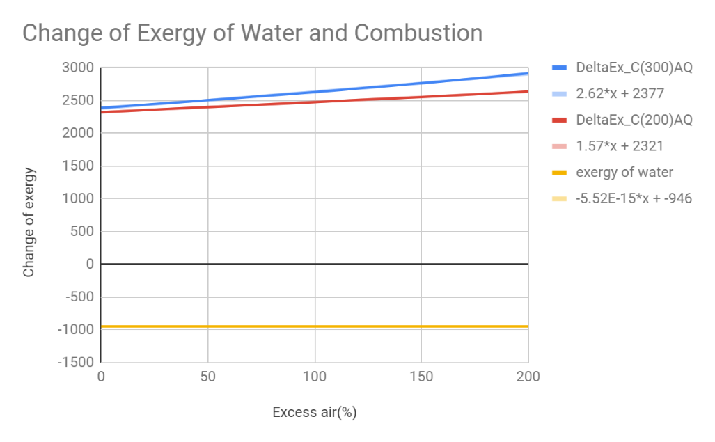

Figure 2

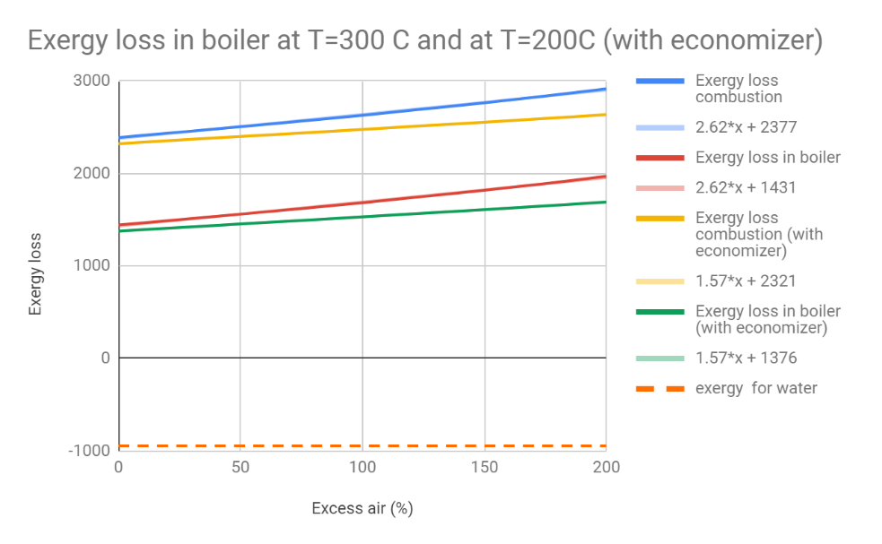

Figure 3

In figure 3, it illustrates the exergy loss in the boiler, exergy loss in combustion and exergy loss in water. The green and red lines in figure 3 represents the total exergy loss in the boiler for when there is an economizer and without. Similarly, the blue and yellow lines are the exergy loss in the combustion for both cases and the orange dash line is the exergy loss in water. From this figure, it shows that the combustion reaction produces a positive exergy while the water produces a negative exergy. This indicates that the combustion reaction is producing the thermal energy while the water is receiving the exergy from the combustion chamber.

Comparing the red line (exergy loss in boiler) and green line (exergy loss in boiler with economizer), it indicates that the exergy loss is reduced when economizer is used. The reason is because the exergy from the combustion products are used to heat up the incoming air in the economizer. As the preheating combustion air is reused in the boiler, more useful energy can be used back in the system which in result reduce the exergy loss.

In addition, it stipulates that when more excess air inserted, the exergy loss in the boiler increases. The reason is that it requires more fuel to not only heat up the water but also to heat up the excess air and that leads to more exergy being produced. From the plot, it also shows a gap increase between the conventional system and the system with the economizer as the percentage of excess air increases. This could be due to the energy produced in the combustion cannot be eliminated. When the product temperature is set to 300 degree Celsius, more energy is required from the combustion to heat up the excess air to 300 degree Celsius. This leads to production of more exergy loss. In comparison to the economizer, the exergy generated is reused to heat up the incoming air while reduce the exergy loss.

**Conclusion**

From the analysis on the results obtained, it shows that with increasing excess air, it will increase the exergy loss in the boiler as some of the heat is used to heat up the air. It also can be concluded that heat transfer of the combustion process cannot be eliminated and thus produces exergy loss. Thus, with the economizer, it helps to reduce the exergy loss because the thermal energy from the combustion are used to heat up the incoming air. In reality, the system will not be adiabatic as there will be heat transfer to the surrounding and the combustion process can be incomplete which leads to other compounds like carbon monoxide to be generated. This can be improved by maintaining proper combustion air temperature and better inlet air preheating.

**References**

1. MORAN, MICHAEL J. FUNDAMENTALS OF ENGINEERING THERMODYNAMICS. JOHN WILEY &amp; SONS, 1988.